# Update expiring Card numbers automatically

Contents

Update expiring Card numbers automatically 1

Class diagram 4

Sequence diagram 4

Logic diagram 6

|  |  |  |  |
| --- | --- | --- | --- |
| **Date** | **Version** | **Author** | **Description** |
| Setp 24, 2014 | 1 | Shane Shou | Initial |

**Introduction**

Detail design about Update expiring Card numbers automatically.

## Class diagram

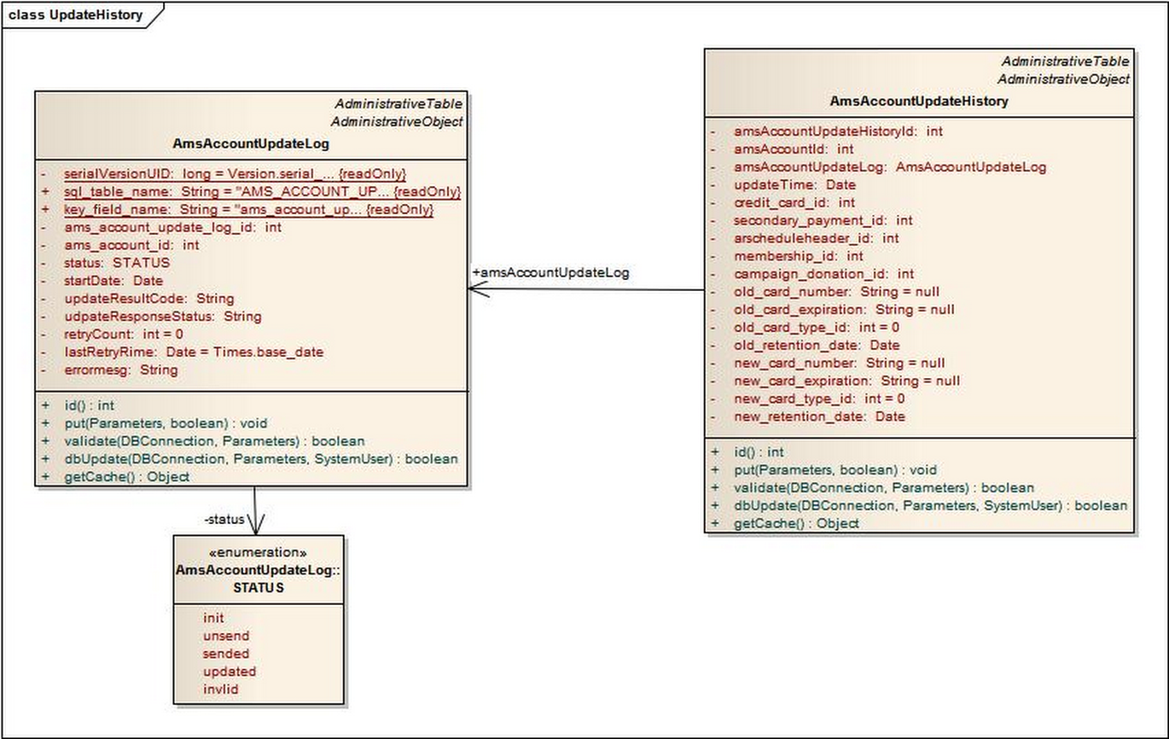

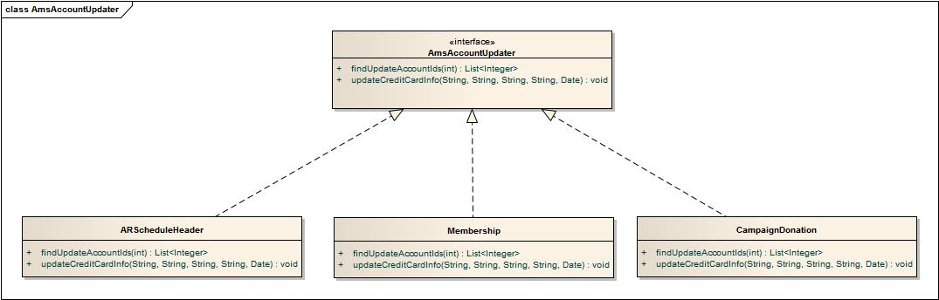

## Sequence diagram

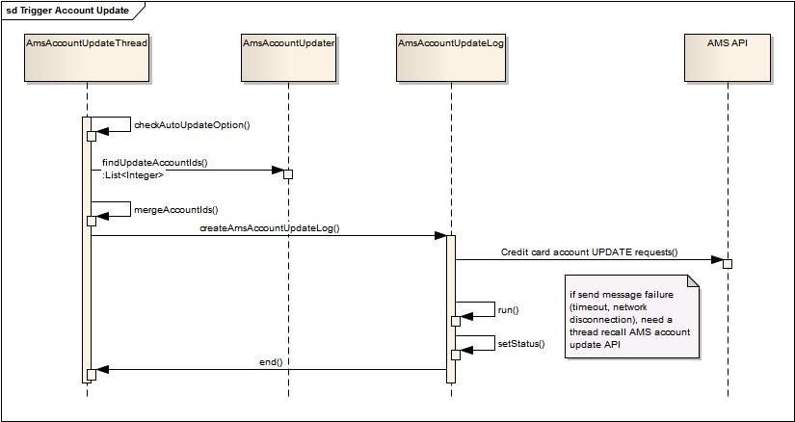

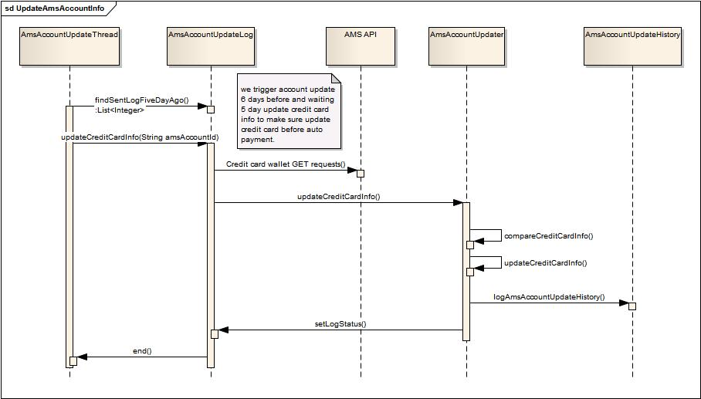

## Logic diagram

